Website Building Scope:
Process Simulator for
Operator Training
&
Process Digital-Twin Models
&
Monte Carlo Models

Engineer: N. Porter
Date: 09 October 2025
Rev.: 1.0

Table of Contents
Project Objectives & Deliverables 4
Project Overview 4
Scope of Work 5
1. Simulator Development 5
1.1 Process Modeling 5
1.2 User Interface Development 5
1.3 Interlock and Scenario Programming 6
1.4 AI Integration 7
2. Configuration and Integration 7
3. Training and Support 7
4. Key Performance Indicators (KPIs) 8
Competitor’s Software Products 8
This Simulator’s Competitive Advantages 9
Project Phases 10
Benefits 11
Assumptions 11
Exclusions 11
Project Stages 11
Project Team: 12
Appendix 1: Software Architecture Overview 13
Appendix 2A: Example Graphic User Interface (GUI) Outputs 17
Appendix 2B: PID Control Dynamics for Each Major Control Loop 19
Appendix 2C: Converter Conversion Graph 21
Appendix 2C: Key Performance Metrics (KPIs) Over Time 23
Appendix 2D: Process Simulation Up-Set & Process Safety Interlock Scenarios 25
Appendix C: Physical Property Generation 27
General Approach to Programming Physical Properties 27
Gas Phase Physical Properties 27
Liquid Phase Physical Properties 27
Steam Physical Properties 27
Appendix D: Description of Matrix Algebra 28

Project Objectives & Deliverables
This project will develop one comprehensive model which will serve a dual purpose. By producing a single simulation, enhancing the project’s overall value.
- An industry-leading, high-fidelity, dynamic Operator Training Simulator (OTS) tailored to the client’s specific plant configuration. The simulator will enhance operator training, improve safety, optimize unit performance, and ensure compliance with environmental and operational standards, delivering a competitive edge in a safe, controlled training environment.

- A high-fidelity Process Digital-Twin Predictive Model. The model is a sophisticated virtual representation of a physical process system that mirrors its behavior with exceptional accuracy. This model integrates real-time data streams, historical performance metrics, and advanced simulation algorithms to replicate the dynamics of the actual process. Its key features include precise modeling of physical and chemical interactions, continuous synchronization with operational data, and the ability to run predictive scenarios. The benefits of this model lie in its capacity to forecast system performance, detect anomalies before they escalate, and optimize operations without interrupting the real process. The advantages are substantial: it enhances decision-making, reduces downtime, improves safety, and supports proactive maintenance strategies—all while lowering operational costs and increasing overall efficiency.

- A Monte Carlo Simulation is a powerful statistical method utilized in process simulations to analyze the impact of risk and uncertainty in plant operations. In the context of this project, the application of Monte Carlo techniques will provide a robust framework for assessing various scenarios affecting system outputs, ultimately leading to optimized performance and enhanced decision-making.

Scope of Work

1. Simulator Development

1.1 Process Modeling
- Description: Develop a dynamic model of the entire process system, including:
  - Catalytic reactors.
  - Conversion and heat exchange systems.
  - Strong acid and chemical absorption units.
  - Heat Recovery Systems.
  - Tail gas scrubbers and stack emissions for environmental performance.
- Software Selection:
  - Open source / free software Python-based backend with Conda for the front-end GUI, offering cost savings, high customizability, and faster development to meet the accelerated timeline.
  - Built on the previous knowledge of simulator programming.
- Customization: Tailor the model to the client’s plant-specific configuration, including equipment sizes, tag names, control logic, and process conditions.
- Deliverables:
  - Steady-state and dynamic process models.
  - Integration with client’s Distributed Control System (DCS) screens, replicating operator console functions.
  - Process Digital-Twin model

1.2 User Interface Development
- Description: Create an interactive graphical user interface (GUI) resembling the client’s DCS screens, enabling operators to:
  - View and adjust controllers, switches, set points, and alarms.
  - Monitor trend lines for real-time tracking of process variables.
  - Access a library of operational scenarios, including normal operations, suboptimal conditions, and emergency scenarios (e.g., pump failures, compressor trips).
- Features:
  - Simulation speeds up to 10x real-time for accelerated training.
  - Side windows displaying the PID control loop dynamics, allowing operators to adjust controller gains for optimization.
  - Warning and error messages for critical conditions (e.g., boiler leaks, line plugging).
  - KPI dashboard showing projected plant performance versus control variable adjustments.
- Deliverables:
  - Custom GUI tailored to client’s DCS layout.
  - Scenario library with all pre-configured scenarios listed in the P&ID Interlock list.

1.3 Interlock and Scenario Programming
- Description: Program interlock trip scenarios and upset conditions to simulate real-world challenges, including:
  - Boiler leaks, line plugging, pump failures, compressor trips, and power failures.
  - Gradual escalation of issues to train operators in early detection and response.
  - Emergency shutdown and purge procedures for SO₂/SO₃ gases.
- Features:
  - Scenarios designed to test operator responses to abnormal conditions.
  - Built-in analytical tools to measure operator competency, knowledge retention, and performance against key training goals.
- Deliverables:
  - Scenario library with documented interlocks.
  - Performance tracking and reporting system.

1.4 AI Integration
- Description: Incorporate an AI assistant to provide real-time operator feedback and guidance, enhancing decision-making and skill development. Include a neural network to optimize plant set-points for maximum efficiency and performance.
- Deliverables:
  - AI assistant integrated into the simulator interface.
  - Neural network module for plant optimization.

Configuration and Integration
- Description: Configure the simulator for flexible deployment, supporting:
  - Stand-alone PC workstation for independent training.
  - Integration with the client’s DCS for control logic debugging and Management of Change (MOC) processes.
  - Separate student and trainer workstations, allowing trainers to initiate scenarios and monitor responses.
- Deliverables:
  - Configured simulator compatible with client’s DCS or stand-alone setup.
  - Documentation for integration and operation.

3. Training and Support
- Description: Provide streamlined training and support to ensure effective adoption, including:
  - Online training sessions on simulator use.
  - Hands-on scenarios for startup, shutdown, and emergency response procedures.
  - Technical support for simulator maintenance and updates.
- Deliverables:
  - Training manuals and scenario guides.
  - 6 months of technical support with optional service agreements.

4. Key Performance Indicators (KPIs)
- Description: Implement KPI tracking to evaluate plant performance based on operator inputs, including:
  - Safety metrics (e.g., response time to emergencies).
  - Efficiency metrics (e.g., energy consumption, acid production rate).
  - Environmental metrics (e.g., stack emissions compliance).
- Features: Real-time comparison of projected plant KPIs versus operator-modified control variables.
- Deliverables:
  - KPI dashboard integrated into the GUI.
  - Reports correlating operator actions to plant performance.

Competitor’s Software Products
- Elessent Clean Technologies (MECS®):
  - Advantages: Proprietary TMODS™ engine with proven reliability since 1988, highly customizable to plant configurations, integrates with DCS for realistic training.
  - Disadvantages: Lacks projected KPI visualization versus control variable changes, no AI assistant or neural network for optimization, high cost (~$500,000–$800,000).
- Honeywell (UniSim Design):
  - Advantages: Integrates with multiple control systems (e.g., Siemens, Emerson), robust simulation technology for offline process design and training, supports digital twin applications.
  - Disadvantages: Limited focus on specific processes, no AI-driven operator feedback, less customizable for niche applications, high licensing costs.
- Siemens (Plant Simulation):
  - Advantages: Strong in discrete-event simulation and 3D modeling, suitable for broad manufacturing applications, supports digital twin integration.
  - Disadvantages: Not tailored for specific processes, lacks dynamic chemical process simulation, no AI or neural network features, complex for operator training.
- Others (e.g., AVEVA):
  - Advantages: Advanced training tools for general process industries, realistic control room simulations.
  - Disadvantages: Generic solutions not specific to targeted technologies, no AI or neural network capabilities, moderate customization.

This Simulator’s Competitive Advantages
- KPI Visualization: Unlike Elessent, our simulator displays projected plant KPIs versus control variable adjustments, enabling operators to optimize performance in real-time.
- AI-Driven Feedback: Integrates an AI assistant for real-time operator guidance, a feature absent in Elessent, Honeywell, Siemens, and AVEVA solutions.
- Neural Network Optimization: Includes a neural network to identify optimal plant set-points, surpassing competitors’ static simulation approaches.
- Cost Efficiency: Python/Conda option reducing costs compared to Elessent’s and Honeywell’s proprietary software, offering similar or superior functionality.
- Rapid Development: Accelerated 3 to 6 month timeline leverages open-source flexibility, outpacing competitors’ longer development cycles.
- Tailored Customization: Matches Elessent’s customization but enhances it with AI and KPI features, ensuring relevance to the client’s specific plant.

Project Phases
- Project Scope Development
  - System Architecture
    - Define what functionality the system will contain
    - Define system Inputs / Outputs
    - Define network architecture, what software will run the system, where the system will live, and how the system will be accessed.
- Phase 1: Static Simulation
  - Develop a steady-state model predicting output variables based on equipment sizes and set points.
  - Display values and KPIs in the GUI.
- Phase 2: Dynamic Simulation and AI Integration
  - Create a dynamic model with time-step transitions and PID control loop visualization.
  - Integrate AI assistant and neural network for feedback and optimization.
  - Implement warning and error messages.
- Phase 3: Scenario Development and Delivery
  - Program interlock trips and upset scenarios with gradual escalation.
  - Conduct testing with client feedback and deliver final simulator, training, and documentation.

Benefits
- Safety and Reliability: Practice upset scenarios in a safe environment, improving operator response and reducing incidents.
- Unit Performance: Optimize operations with AI-driven insights and standardized responses, minimizing process swings.
- Training Effectiveness: Deliver hands-on, AI-enhanced training with immediate feedback, boosting competency and retention.
- Competitive Edge: Outperform competitors with cost-effective, AI-integrated, and highly customizable training solutions.

Assumptions
- Client will provide detailed plant data (e.g., P&IDs, equipment sizes, DCS configurations) within the first week to meet the full timeline.
- Simulator scope aligns with industry-leading features, enhanced by AI and KPI visualization.
- Open-source software (Python/Kivy/Conda) is prioritized to meet timeline and cost goals.

Exclusions
- Hardware procurement (e.g., workstations, servers) unless specified.
- On-site installation unless agreed upon in the contract.
- Ongoing maintenance beyond the initial 6-month support period.

Project Stages
- Part 1: Stand-up the simulation (get the simulation up and running)
  - Static Model
  - Dynamic Model
  - Interlock and Upset Conditions
  - Neural Net Training & Optimization
- Part 2: Tune the system to match the physical plant

Project Team:
- Software Architecture & Project Management: Nathan Porter
  - Designs the overall software functionality
  - Manages the team and the project
  - In charge of strategy
- Full-Stack Engineer Consultant:
  - Modifies the python code
  - Passes inputs & outputs to the Graphic User Interface (GUI)
  - Produces the GUI
  - Creates all user interfaces
- Automation & Controls Engineer Consultant: Ensures the loop tuning in the process model matches the actual controllers in the field, to create a more realistic understanding of system dynamics.
- PhD Kinetics Consultant:
  - Ensures that the mathematical equations are appropriate
  - Tunes the model in accordance with data

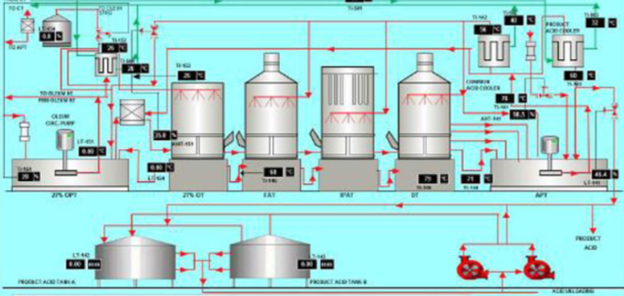
Appendix 2A: Example Graphic User Interface (GUI) Outputs

This graphic depicts the GUI a detailed process flow diagram simulating a chemical plant layout, including tanks, pumps, coolers, and labeled parameters like temperatures, levels, and flows.
GUI Features

- Mirrors the real Distributed Control System (DCS) layout with identical unit operations. (e.g., circulation pumps, reactors, coolers, product tanks) and screen positions. - Includes real-time data displays for variables such as temperature (e.g., 20 C, 72C), levels (e.g., 85.5%), and flows (e.g., in gpm, mass flow, and valve open percentage).
- Visual elements like arrows for flow directions, icons for equipment, and color-coded lines for process streams.

GUI Advantages
- Provides a familiar interface that reduces the learning curve for operators transitioning from simulation to real operations—superior to generic simulators like Aspen HYSYS or AVEVA OTS, which often use stylized or DOS-agnostic interfaces that can lead to adaptation issues and lower training fidelity.
- Allows interactive monitoring of multiple interconnected units in one view, enabling quick identification of system-wide interactions, unlike simpler tools such as Equinox OTS that may lack exact layout replication and result in less intuitive navigation.
- High-fidelity replication ensures accurate representation without oversimplification, supporting precise training scenarios, outperforming basic virtual plants in Yokogawa OTS by minimizing discrepancies between sim and reality.

GUI Benefits
- Boosts profits by accelerating operator proficiency, cutting training costs by up to 30% through reduced on-site practice time and minimizing production downtime from human errors.
- Enhances safety by enabling risk-free rehearsal of complex operations, potentially lowering accident rates as operators gain confidence in handling real DCS emergencies.
- Promotes sustainability through better process understanding, leading to optimized resource use and reduced waste, which can decrease emissions and energy consumption by 10-15%, improving environmental compliance and long-term cost savings.

Appendix 2B: PID Control Dynamics for Each Major Control Loop
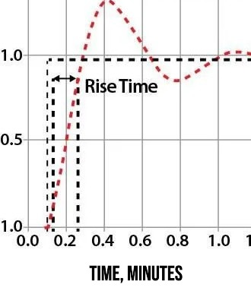
Temperature, Pressure, Flow, Level, etc.
Previous Set Point
New Set Point

This graphic shows a line graph of a PID controller response, illustrating rise time with a curve overshooting and settling, accompanied by notes on computational methods.

Features
- Plots process variable (normalized 0-1) against time (in minutes), highlighting "Rise Time" with a dashed line and arrow.

- Incorporates notes on using linear-matrix algebra for data points, visualization of equilibration between start/end points, and options for real-time or accelerated simulation.
- Demonstrates dynamic behavior like overshoot and settling for major control loops.

Advantages
- Simplifies complex PID dynamics by using linear approximations instead of non-linear calculus, making computations faster and more accessible—better than high-end simulators like Topsoe OTS or TSC Simulation, which rely on computationally intensive full non-linear models that can slow down training sessions on standard hardware. - Allows users to observe system responses in compressed time, facilitating rapid iteration during training, an edge over tools like Cape Software that may not offer seamless acceleration, leading to longer wait times for scenario outcomes.
- Provides visual clarity on control stability, helping identify tuning issues without realworld trials, surpassing basic PID visualizations in UniSim by enabling quicker, more efficient tuning explorations.

Benefits

- Increases profits by speeding up control system training, reducing operational inefficiencies and enabling faster plant startups, which can save thousands in lost production hours annually.
- Improves safety through simulated equilibration practice, preventing unstable loops that could cause real-world incidents, potentially cutting incident-related costs and liabilities by 25%.
- Supports sustainability by allowing operators to fine-tune for minimal energy use and emissions during transients, contributing to greener operations and regulatory credits that enhance bottom-line savings.
NOTES:
Note 1: The program will utilize linear-matrix algebra to create each data point instead of solving non-linear calculus.
Note 2: The program allows the operator to see the system equilibrate between a starting point and ending point
Note 3: The program can be run either in real time or an accelerated compared to the real system lag time.

Appendix 2C: Converter Conversion Graph
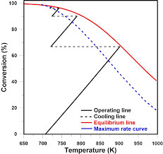

Description: This graphic is a plot of conversion percentage versus temperature (in Kelvin), comparing operating line, cooling line, equilibrium line, ana maximum rate curve.
Features of the Converter Conversion Graph
- Multi-line graph showing conversion (%) from 0-100 against temperature (650-1000K), with lines for operating (dashed black), cooling (dotted black), equilibrium (red), and maximum rate (blue).
- Illustrates key intersections and trends, such as decreasing conversion with increasing temperature post-peak.
- Focuses on classic converter behavior in a chemical process context.

Advantages of the Converter Conversion Graph
- Visually compares theoretical limits (equilibrium, max rate) with practical paths (operating, cooling), aiding in understanding trade-offs—more insightful than standard graphs in AspenTech OTS, which may not integrate such multi-curve comparisons for quick optimization insights.
- Condenses complex thermodynamic data into an intuitive format, easier to interpret than raw equations, outperforming tools like Yokogawa OTS that often prioritize operational views over theoretical overlays, limiting deeper kinetic analysis.
- Highlights optimal operating regions, supporting quick analysis of temperature impacts on efficiency, a step ahead of generic simulators like Simulate Live that lack specialized converter-focused visualizations.

Benefits of the Converter Conversion Graph
- Drives profits by guiding operators to maximize yields in converters, potentially increasing production efficiency by helping the engineers and operators understand exactly where to optimize SO2 conversion.
- Reduces emissions by being able to visually and empirically identify optimization opportunities in each converter pass.
- Advances sustainability through optimized temperature control, minimizing temperature oscillations that would result in inefficient conversions, which can cause the process to miss key performance objectives.

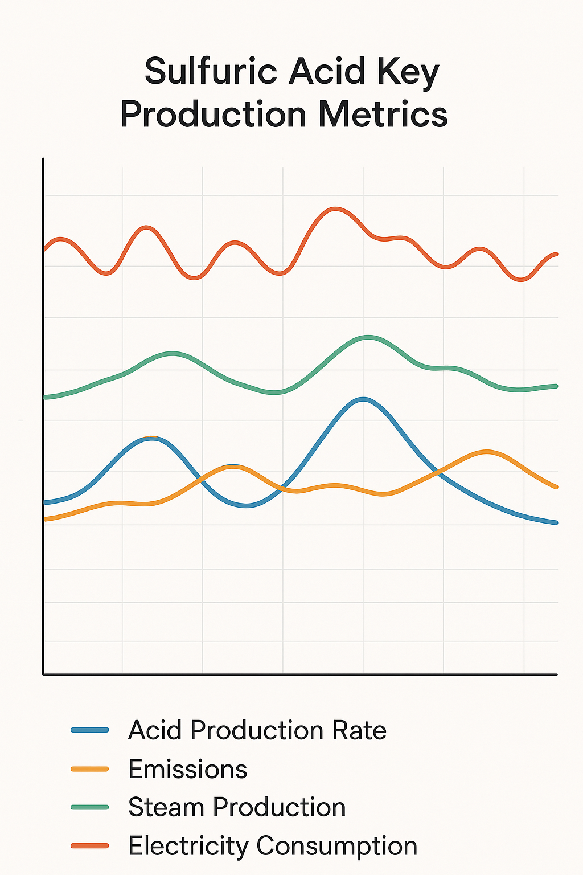
Appendix 2C: Key Performance Metrics (KPIs) Over Time

Description: This graphic is a multi-line chart tracking process production metrics, including acid production rate (blue), emissions (orange), steam production (green), and electricity consumption (red) over an unspecified time axis.
6)
Features of Production Metrics Output
- Overlaid lines for four KPls: Acid Production Rate, Emissions, Steam Production, and Electricity Consumption, showing fluctuations and trends.
- Analyzes the data looking for patterns and shows how KPI improve over time.
- Displays correlated behaviors, such as peaks and troughs across metrics, implying process interdependencies.

Advantages of Production Metrics Output
- Enables simultaneous monitoring of multiple interrelated KPls, revealing patterns like how production rate affects emissions—superior to fragmented KPI displays in tools which may not correlate metrics in a single view for holistic analysis.
- Uses a time-based view to track dynamic changes, better than static snapshots for understanding variability, an improvement over basic charting in Cape Software that lacks overlaid interdependencies.
- Simplifies data interpretation through color coding and smooth lines, making it accessible for non-experts, unlike more technical interfaces in TSC Simulation that can overwhelm with raw data.

Benefits of Production Metrics Output
- Enhances profits by identifying optimization opportunities, such as balancing production with energy use, leading to cost reductions in utilities and higher output margins.
- Strengthens safety by spotting anomalous trends early, preventing escalations that could cause shutdowns or hazards, thus avoiding costly incidents.
- Fosters sustainability by visualizing emission and consumption patterns, enabling reductions that comply with regulations and reduce carbon taxes or penalties.

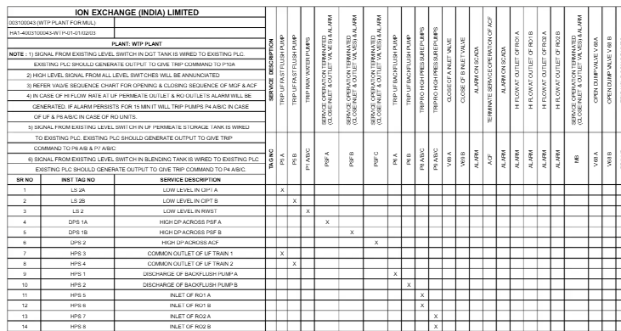
Appendix 2D: Process Simulation Up-Set & Process Safety Interlock Scenarios

This graphic is a table listing upset scenarios with corresponding safety interlocks, including signal sources, descriptions, and alarm triggers marked with "X."

Features
- Incorporates all safety interlocks and alarms. (High, High-High, Low, Low-Low)
- Covers unfortunate scenarios real-world process plant issues such as:
  - Loss of a pump.
  - Spray nozzles falling off.
  - Pipes rupturing
  - Compressor Vibrations
  - Acid temperature excursion
  - Low-low liquid levels
  - Etc.
- Includes detailed notes on signals from existing PLCs, trip commands to ABC, and interlock logic like valve closures or pump trips.

Advantages
- Organizes complex safety logic into a clear, scannable grid, reducing the chance of overlooking critical interlocks—more user-friendly than dense text-based scenarios in AVEVA OTS, which can complicate quick reference during training.
- Allows simulation of upsets without real risks, testing responses in a controlled environment, better than partial scenario coverage in Equinox OTS that may miss comprehensive interlock mappings.
- Comprehensive coverage of scenarios ensures all potential failures are addressed, from low levels to high pressures, surpassing limited upset libraries in Topsoe OTS by providing plant-specific depth.

Benefits
- Improves profits through proactive upset training, minimizing unplanned downtimes that can cost millions in lost production.
- Elevates safety by simulating interlocks, reducing human-error incidents and associated insurance premiums or fines.
- Contributes to sustainability by preparing operators to handle scenarios that prevent spills or excess emissions, ensuring compliance and avoiding environmental cleanup costs.

Appendix C: Monte Carlo

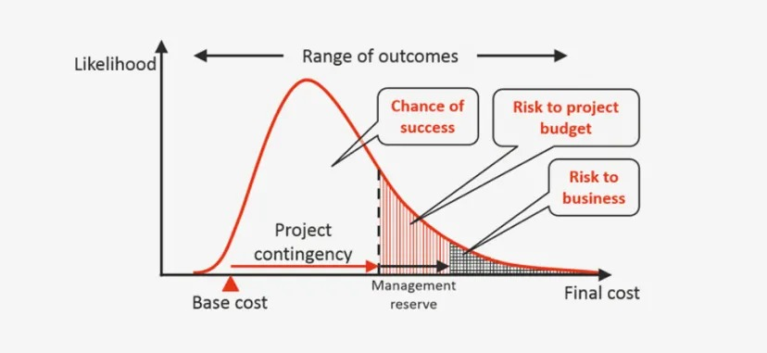

Monte Carlo Overview
Monte Carlo simulation is a powerful statistical method utilized in process simulations to analyze the impact of risk and uncertainty in plant operations. In the context of this project, the application of Monte Carlo techniques will provide a robust framework for assessing various scenarios affecting system outputs, ultimately leading to optimized performance and enhanced decision-making.
By employing Monte Carlo simulations, the project aims to account for a wide range of variables including feedstock variability, equipment performance, and market conditions. This stochastic approach enables the generation of multiple potential outcomes based on randomly sampled input parameters, allowing stakeholders to visualize the potential range of system performance and identify key drivers of efficiency.
Incorporating Monte Carlo methods will facilitate:
- Risk Assessment: Understanding the likelihood and impact of adverse events on plant operations, enabling proactive measures to be implemented.
- Scenario Analysis: Evaluating how different operational strategies and process adjustments can affect output, helping operators to make informed decisions that maximize productivity.
- Optimization of Processes: Identifying optimal operating conditions and configurations that enhance overall system outputs while minimizing costs and environmental impact.
By integrating Monte Carlo simulations into both the operator training simulator (OTS) and the process digital-twin predictive analytic model, the project seeks to deliver a comprehensive toolset that not only trains operators on best practices but also equips them with predictive insights for real-time decision-making. This holistic approach aims to maximize system outputs while ensuring safety and compliance, thereby providing a significant strategic advantage in the competitive market landscape.

Appendix D: Physical Property Generation

General Approach to Programming Physical Properties
Physical properties for this project’s needs are easily obtainable through Aspen Plus or the standard steam tables. In the documentation for Aspen Plus the methods for calculating items such as the heat capacity of liquids can come from an activity coefficient model with complex entropy and enthalpy correction factors. This work will take the final output of the model and program the data into the simulation. Unlike the Aspen Plus method of calculations, there is no need to redo or recreate the calculations for each simulation run.

Gas Phase Physical Properties
The gas phase physical properties are well known. For the purpose of this work the ideal gas equation should be adequate.

Liquid Phase Physical Properties
The heat capacities for liquids will be taken from Aspen Plus’ physical property generation software as a table or graph. This data will be programmed into the simulation.

Steam Physical Properties
The steam tables will be utilized for steam physical properties.

Appendix E: Description of Matrix Algebra
The system’s computations will almost exclusively utilize NumPy, which is a linear matrix programming language, with a possible exception of utilizing PsiPy, which is a non-linear equation solver on some of the converter reactions.
By keeping as many of the equations linear, it allows the simulation to converge rapidly, as opposed to having non-linear equations which require a root-finding algorithm. This software avoid the need for solve complex differential equations by re-running the simulation linearly to obtain each data point in the dynamic mode.

